**User Manual**

**for**

**PC2 Web Team Interface**

**Version 2.0**

**Prepared by:   
Josie Isaacson  
Andrew Combs  
Ethan Holman  
Danielle Frodge**

**EWU CS Department**

**Winter 2019/Spring 2019**

Table of Contents

**Introduction** **2**

**Login** **2**

**Submitting a Problem for Judgement** **3**

**Submitting a Problem for Testing** **4**

**Viewing Run Results** **6**

**Requesting a Clarification** **8**

**Viewing Clarifications** **9**

**Options** **10**

**Logout** **11**

**About Information** **12**

# Introduction

This user manual is intended for teams to reference while using the PC2 Web Team Interface (WTI).

# Login

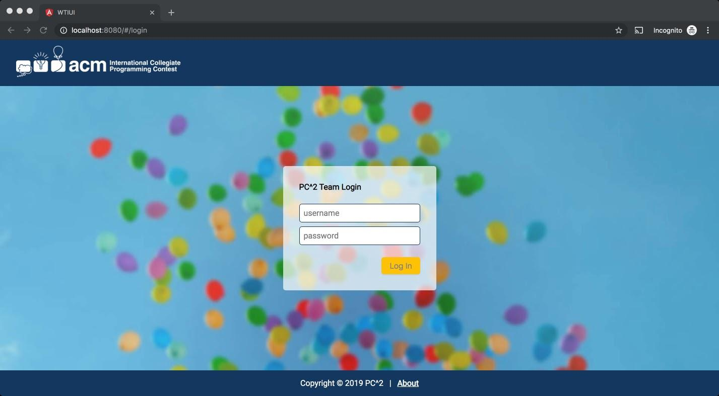

To login to PC2:

* Click on the **Username** box and enter your assigned team ID.
  + Your team ID will be of the form teamXX, where XX is your assigned team number.
  + For example: “team2” or “team15”
* Click on the **Password** box and enter your assigned password.
* Click on the **Login** button.

# Submitting a Problem for Judgement

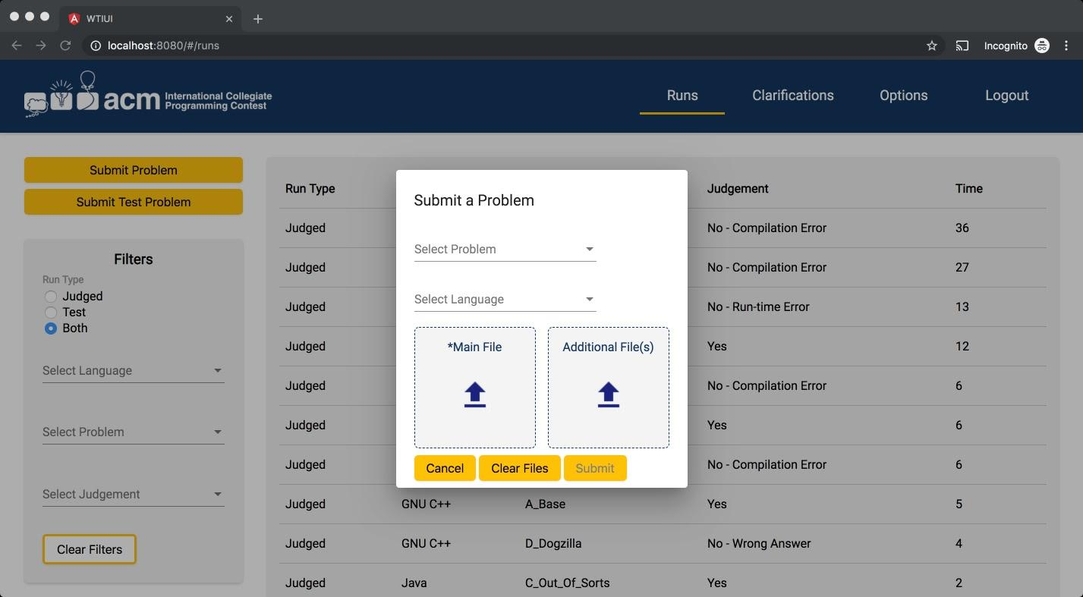

To submit a problem to be judged:

* Click on the **Runs** tab at the top of the page.
* Click on the **Submit Problem** button in the upper left hand corner of the runs screen.
* A pop-up will display with the title “Submit a Problem.”
* Select the problem you are submitting a solution for from the drop down list titled **Select Problem**.
* Select the language that the solution you are submitting uses from the drop down list titled **Select Language**.
* Select the main file that contains your solution. Click on the  in the box titled **Main File**. This will display a file dialog which will allow you to locate and select your main file. Select only source code files for submission. Do not submit data files or executable files.
* If additional source code files are needed for your solution, you can click on the  in the box titled **Additional File(s)**. This will display another file dialog which will allow you to locate and select your additional file(s).
* At a minimum, your submission must include a selected problem, a selected language, and a selected main file.
* Once you have made the necessary selections, you can click the **Submit** button to submit your solution to be judged. If you decide that you do not want to submit your solution at this time, click the **Cancel** button to be returned to the runs screen.

# Submitting a Problem for Testing

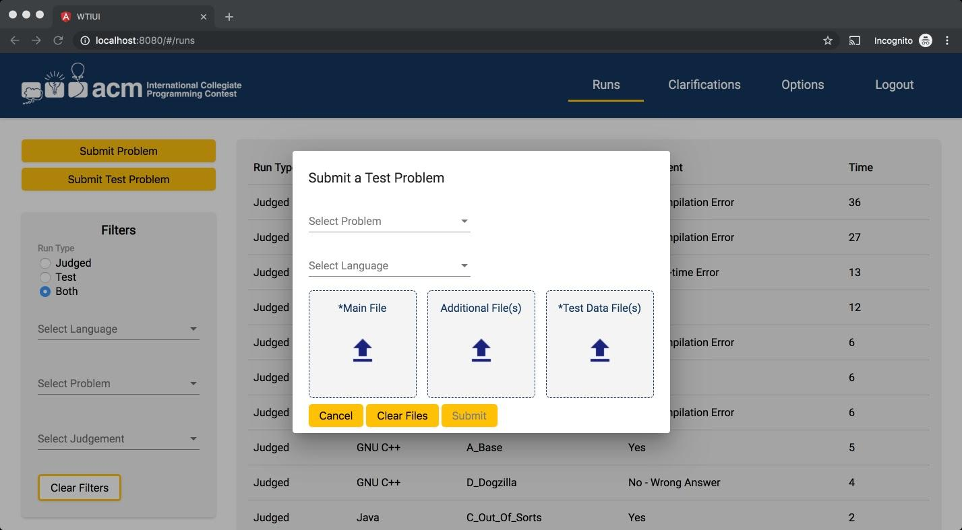

Submitting a problem for testing means that the submitted test solution will compile and execute your test solution using an environment as nearly identical to the environment the judges will be using as possible, except that it will be *using your data file* instead of the data file used by the judges.

It is ***important*** to submit a problem for testing before submitting your solution for judgement. Just because your program runs the way you intend in the development environment you used to create your solution **does not** mean that it will necessarily run precisely the same way in the environment used by the judges. Test runs do not count against your score in the contest, but they may save you a lot of time and penalty points by identifying environment problems or differences *before* you submit your solution to the judges.

To submit a problem to be tested:

* Click on the **Runs** tab at the top of the page.
* Click on the **Submit Test Problem** button in the upper left hand corner of the runs screen.
* A pop-up will display with the title “Submit a Test Problem.”
* Select the problem you are submitting a test solution for from the drop down list titled **Select Problem**.
* Select the language that the test solution you are submitting uses from the drop down list titled **Select Language**.
* Select the main file that contains your test solution. Click on the  in the box titled **Main File**. This will display a file dialog which will allow you to locate and select your main file. Select only source code files for submission. Do not submit data files or executable files.
* If additional source code files are needed for your test solution, you can click the  in the box titled **Additional File(s)** button. This will display another file dialog which will allow you to locate and select your additional file(s).
* *If the selected problem requires a test data file*, select the test data file for your test solution. Click on the  in the box titled **Test Data File(s)**. This will display a file dialog which will allow you to locate and select your test data file. Select only text files for submission.
* Once you have made the necessary selections, you can click the **Submit** button to submit your solution to be tested. If you decide that you do not want to submit your solution to be tested at this time, click the **Cancel** button to be returned to the runs screen.

# Viewing Run Results

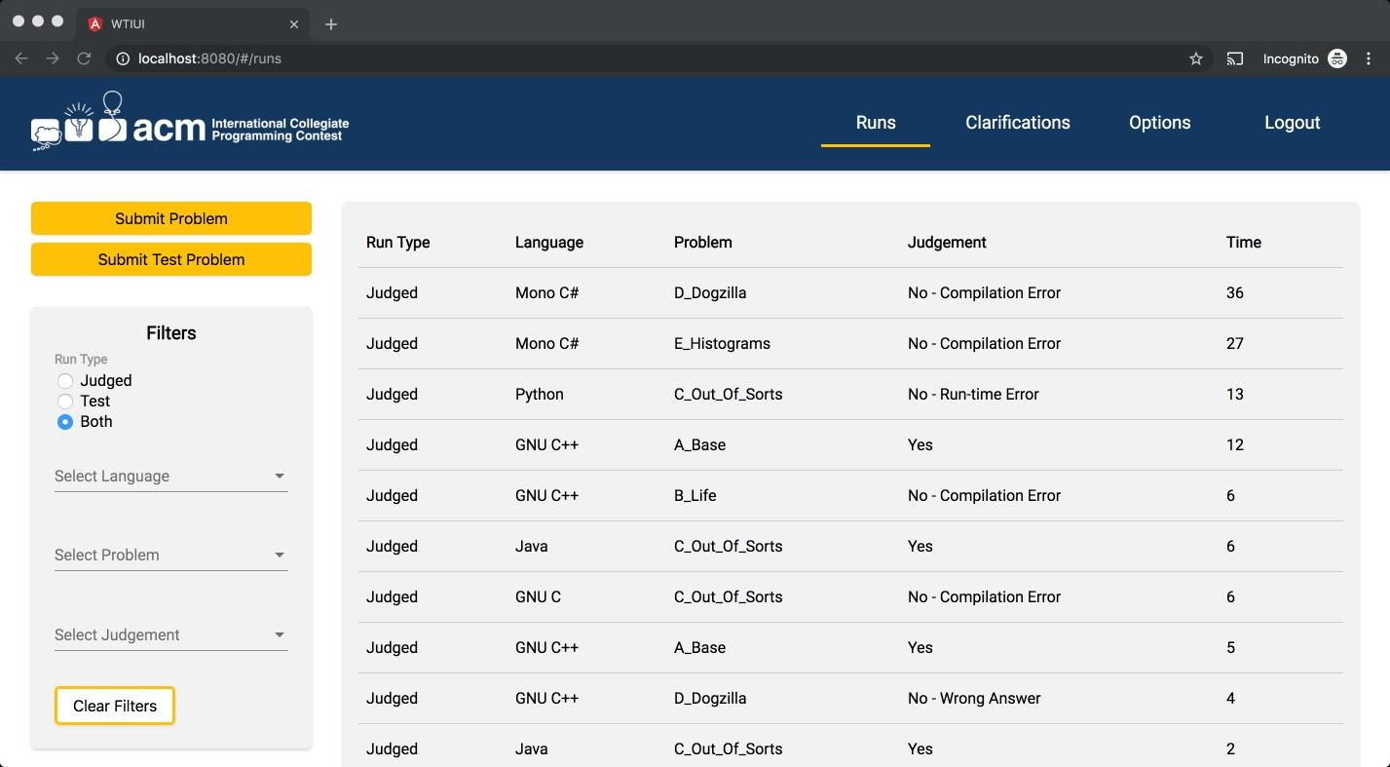

To view all runs submitted:

* Click on the **Runs** tab at the top of the page.
* The runs page contains a table that displays all runs (both submitted for testing and for judging). Runs information includes the **Run Type**, the **Language** the solution was done in, the **Problem** the solution was submitted for, the **Judgement** received for the submission, the **Time** the run was submitted, and if the run was a test run, a link to view the test output results from the submitted test run.

Filtering views:

* There are four filters that can be used to filter the runs being displayed in the runs table: *run type, language, problem, and judgement.*
  + Filtering by **Run Type**:
    - If you want to filter runs to view *only runs submitted for judging*, click on the **Judged** radio button under the run type filter heading.
    - If you want to filter runs to view *only runs submitted for testing*, click on the **Test** radio button under the run type filter heading.
    - By default (if no run type filter is chosen) or if the **Both** radio button is clicked, all run types will be displayed.
  + Filtering by **Language**:
    - If you want to filter runs to view *only runs submitted for a single language*, click on the **Select Language** drop down list. Select the language you want to filter by.
  + Filtering by **Problem**:
    - If you want to filter runs to view *only runs submitted for a single problem*, click on the **Select Problem** drop down list. Select the problem you want to filter by.
  + Filtering by **Judgement**:
    - If you want to filter runs to view *only runs submitted for a single judgement*, click on the **Select Judgement** drop down list. Select the judgement you want to filter by.
  + Filters can be used in combination. To clear all filter selections, click the **Clear Filters** button.

To view results from a test run:

* Click on the **View Results** link that is displayed on the right hand side of the test run you want to view the results for.
* A pop-up will display with the title View Test Results.

Notes:

* Preliminary Judgements:
  + Contest admin may choose to enable auto judging for some or all problems. This means that a problem will be judged automatically by the PC2 system and will display to you a preliminary judgement. This judgement notification will be labeled as a Preliminary Judgement in red font. When the judges manually check the run result and choose a final judgement, you will receive another notification of the Final Judgement.

# Requesting a Clarification

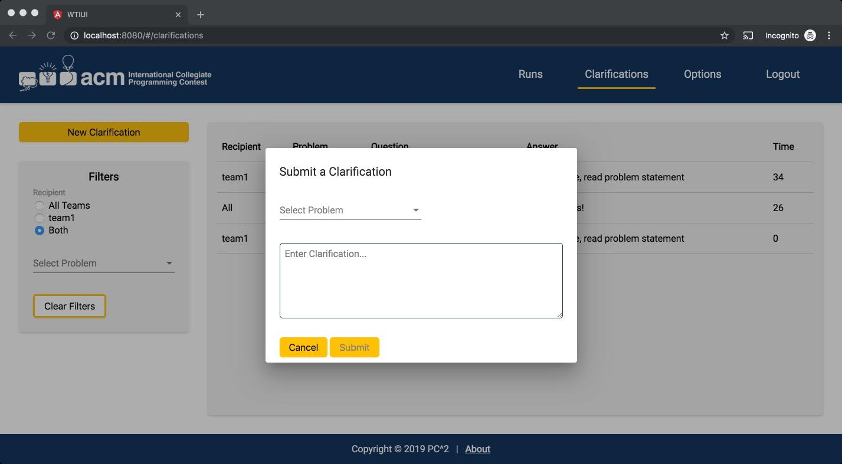

To request a clarification:

* Click on the **Clarifications** tab at the top of the page.
* Click on the **New Clarification** button in the upper left hand corner of the clarifications screen.
* A pop-up will display with the title “Submit a Clarification.”
* Select the problem you are submitting a clarification for from the drop down list titled **Select Problem**.
* Enter your clarification into the text box. Only plain text is allowed.
* Click the **Submit** button. A clarification must have a problem selected and text entered into the text box in order to be submitted.

*Please note that while the contest judges will consider requests for clarification of ambiguities in a problem statement, they will not normally respond to other types of questions. If you submit a clarification which asks about something that the judges feel is adequately covered in the problem statement, they may simply respond to your clarification with an answer such as “No response; Read the problem statement”.*

# Viewing Clarifications

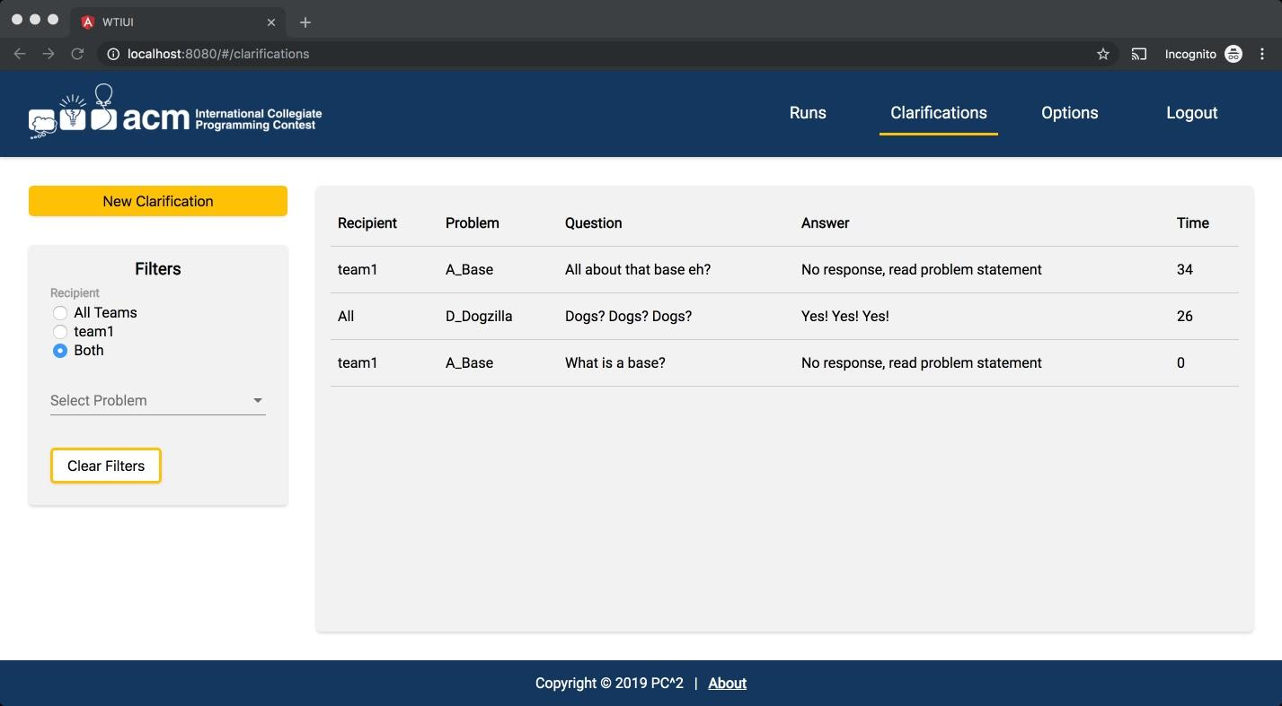

To view all clarifications submitted:

* Click on the **Clarifications** tab at the top of the page.
* The clarifications page contains a table that displays all clarifications (both for All Teams and for current team). Clarifications information includes the **Recipient**, the **Problem** the clarification was submitted for, the **Question** asked in the clarification, the **Answer** provided by the judges for the clarification, and the **Time** the clarification was submitted.

Filtering views:

* There are two filters that can be used to filter the clarifications being displayed in the clarifications table: *recipient and problem.*
  + Filtering by **Recipient**:
    - If you want to filter clarifications to view *only clarifications intended for All Teams*, click on the **All Teams** radio button under the recipient filter heading.
    - If you want to filter clarifications to view *only clarifications intended for only your team*, click on the radio button **labeled with your team name** under the recipient filter heading.
    - By default (if no recipient type filter is chosen) or if the **Both** radio button is clicked, all recipient types will be displayed.

* + Filtering by **Problem**:
    - If you want to filter clarifications to view *only clarifications submitted for a single problem*, click on the **Select Problem** drop down list. Select the problem you want to filter by.

# Options

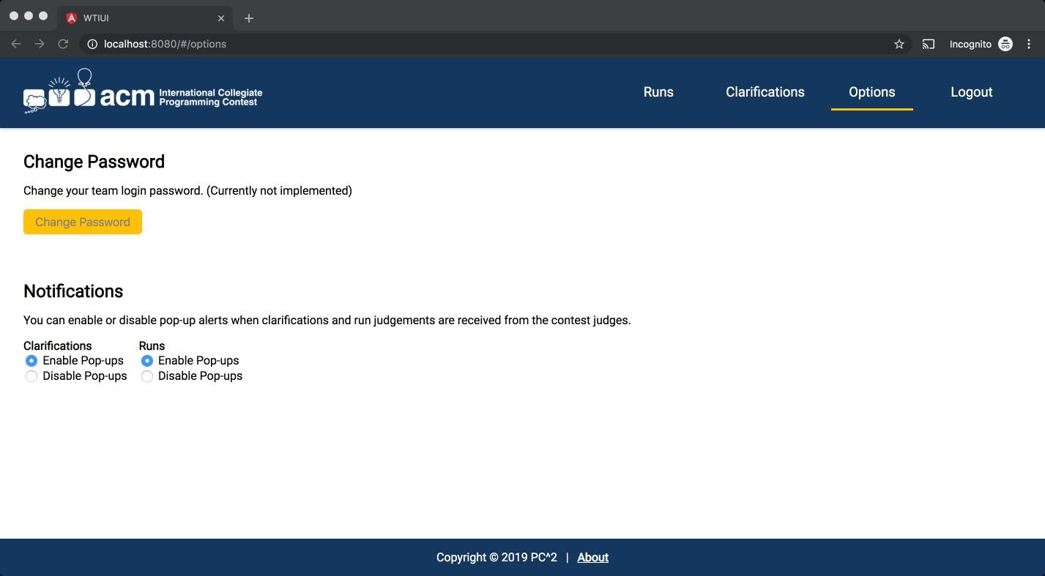

There are two possible contest options: changing your team login password and enabling/disabling certain pop-ups. *These options are at the discretion of the contest administrator, and may or may not be available for your contest.*

To change your team login password:

* Click on the **Options** tab at the top of the page.
* Click on the **Change Password** button located on the left side of the options screen.
* A pop-up will display with the title Change Password.
* Click on the **Current Password** box and enter your assigned team password.
* Click on the **New Password** box and enter the new password you want for your team login credentials.
* Click on the **Re-enter New Password** box and enter the new password you want again.
* Click on the **Submit** button.
* If you do not want to change your password, click the **Cancel** button to be returned to the options screen.

To enable/disable certain pop-ups:

* Click on the **Options** tab at the top of the page.
* To enable pop-ups, click on the **Enable Pop-ups** radio button.
* To disable pop-ups, click on the **Disable Pop-ups** radio button.

# Logout

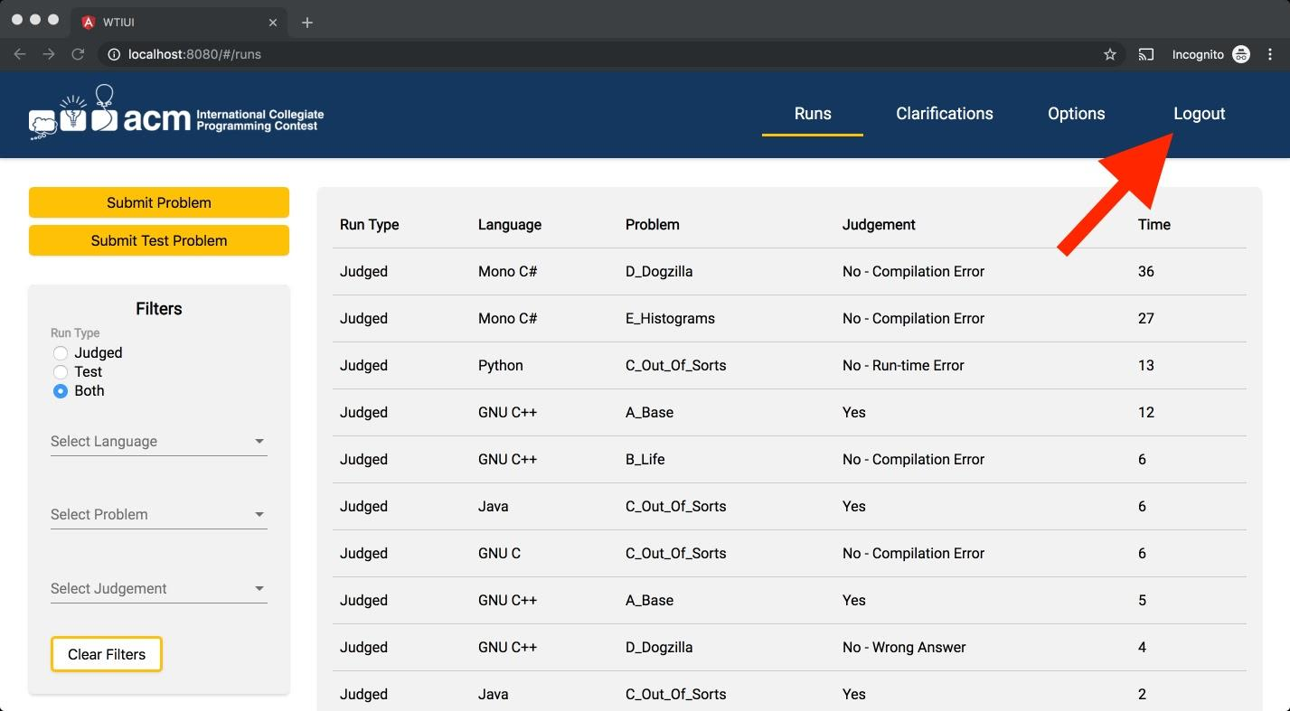

To logout from PC2:

* Click the **Logout** tab at the top of the page.
* You will be returned to the login page.

# About Information

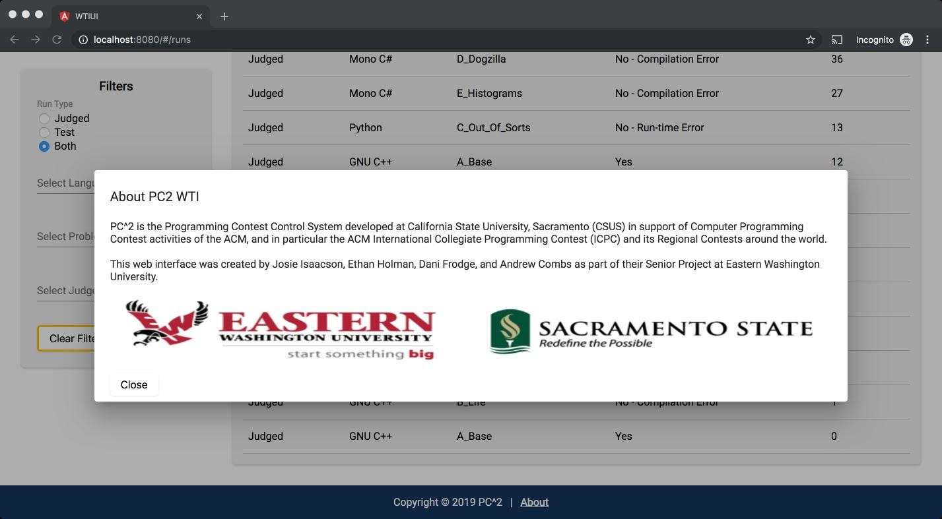

To view information about PC2:

* Click on the **About** link at the bottom of the page. A pop-up will be displayed with information about PC2 and its creators. The link is available at the bottom of any page.
* To exit, click the **Close** button in the lower left hand corner of the pop-up. You will be returned to the page you were on prior to clicking the about information link.